Assignment 2-Case Study

Stage 4 Lab Activities

Implementing the SmartCare Domain Layer
DESIGN FIRST -> AI PAIR PROGRAMMING -> REVIEW -> VERIFY | 1hour

A - Revisit Approved UML
Confirm responsibilities, attributes and relationships before coding.
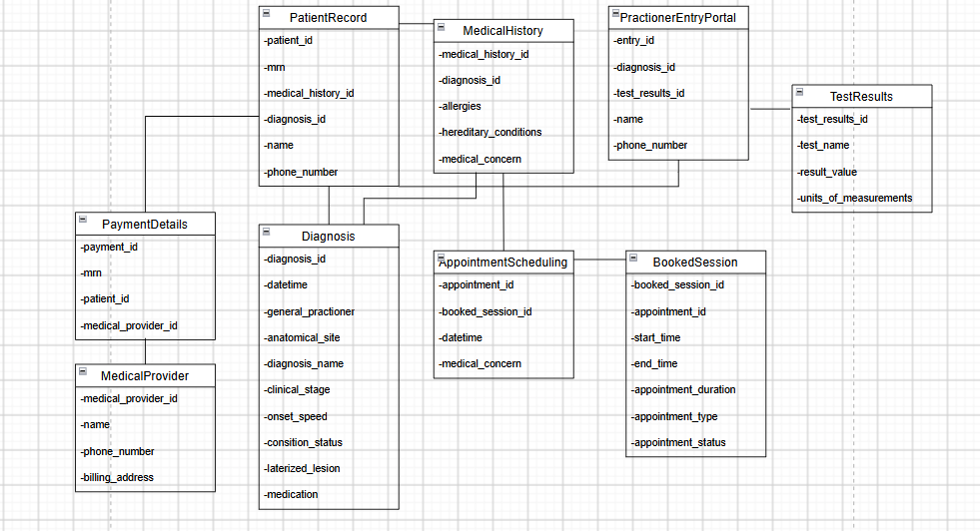

B - Implement Patient: AI OFF
Implement Patient with type hints and basic validation.

C - Implement Practitioner: AI OFF
Implement Practitioner with identifier, name and specialty; no database logic.
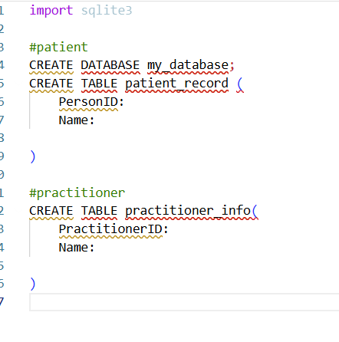

D - Implement Appointment: AI ON
Give AI the approved Appointment UML, business rules and explicit constraints. Ask it to implement only Appointment and agreed enum/exception.

Enums + Exceptions + Appointment class (clean domain model)
python
from enum import Enum

# -----------------------------
# ENUMS
# -----------------------------

class AppointmentStatus(Enum):
BOOKED = "booked"
PENDING = "pending"
RESCHEDULED = "rescheduled"
CANCELLED = "cancelled"

class MedicareRegistration(Enum):
YES = "yes"
NO = "no"

# -----------------------------
# CUSTOM EXCEPTIONS
# -----------------------------

class InvalidAppointmentStatus(Exception):
pass

class InvalidMedicareRegistration(Exception):
pass

class InvalidPhoneNumber(Exception):
pass

# -----------------------------
# APPOINTMENT ENTITY
# -----------------------------

class Appointment:
def __init__(self, appointment_id: int,
status: str,
medicare_registered: str,
phone_number: int):

self.appointment_id = appointment_id

# Validate status
try:
self.status = AppointmentStatus(status.lower())
except ValueError:
raise InvalidAppointmentStatus(
f"Status '{status}' is invalid. Must be one of: "
f"{[s.value for s in AppointmentStatus]}"
)

# Validate medicare registration
try:
self.medicare_registered = MedicareRegistration(medicare_registered.lower())
except ValueError:
raise InvalidMedicareRegistration(
f"Medicare registration '{medicare_registered}' is invalid. "
f"Must be 'yes' or 'no'."
)

# Validate phone number
if not isinstance(phone_number, int):
raise InvalidPhoneNumber(
f"Phone number must be an integer, got {type(phone_number).__name__}"
)
self.phone_number = phone_number

# -----------------------------
# UPDATE METHODS WITH VALIDATION
# -----------------------------

def update_status(self, new_status: str):
try:
self.status = AppointmentStatus(new_status.lower())
except ValueError:
raise InvalidAppointmentStatus(
f"Status '{new_status}' is invalid. Must be one of: "
f"{[s.value for s in AppointmentStatus]}"
)

def update_medicare_registration(self, new_value: str):
try:
self.medicare_registered = MedicareRegistration(new_value.lower())
except ValueError:
raise InvalidMedicareRegistration(
f"Medicare registration '{new_value}' is invalid. "
f"Must be 'yes' or 'no'."
)

def update_phone_number(self, new_number: int):
if not isinstance(new_number, int):
raise InvalidPhoneNumber(
f"Phone number must be an integer, got {type(new_number).__name__}"
)
self.phone_number = new_number

🔍 Why this implementation is strong

1. Enums guarantee correctness
No invalid string can ever slip through — the enum enforces the allowed domain values.

2. Custom exceptions give precise error reporting
Your controller layer (ClinicController, AppointmentManager) can catch these and return clean API errors.

3. All invariants enforced at construction + update
This prevents corrupted Appointment objects from ever existing.

E - Review Generated Code
Check model consistency, unsupported features, public state mutation, unnecessary inheritance, invented dependencies and error handling.

F - Manual Behaviour Checks
Create valid objects, test invalid input, cancel a scheduled appointment and attempt an illegal repeated transition.

G - Refactor
Remove unnecessary code and make implementation simpler and design-consistent.
This will be reviewed and assessed later through the declared implementation parts.

H - AI Engineering Log
Record prompt, generated contribution, decisions and verification evidence.

Suggested AI prompt
Act as a Python pair programmer. Implement only the Appointment class from the approved SmartCare UML. Use type hints and an AppointmentStatus enum. Cancelled appointments remain as objects. Do not add database, UI, notification or service classes. Protect status transitions and explain any decision not directly visible in the UML.

✅ AppointmentStatus Enum
python
from enum import Enum

class AppointmentStatus(Enum):
BOOKED = "booked"
PENDING = "pending"
RESCHEDULED = "rescheduled"
CANCELLED = "cancelled"
This directly reflects the invariant you defined. Enums give you compile-time clarity and runtime safety.

✅ Appointment Class (UML-aligned, no services, no DB, no UI)
python
class Appointment:
def __init__(
self,
appointment_id: int,
start_time: str,
end_time: str,
appointment_type: str,
status: AppointmentStatus
):
self.appointment_id = appointment_id
self.start_time = start_time
self.end_time = end_time
self.appointment_type = appointment_type

# Enforce UML-approved status domain
self._status = status

@property
def status(self) -> AppointmentStatus:
return self._status

def update_status(self, new_status: AppointmentStatus) -> None:
"""
Protects illegal transitions.
Cancelled appointments remain as objects but cannot transition out.
"""

# Decision 1: Cancelled → anything else is forbidden
if self._status is AppointmentStatus.CANCELLED:
raise ValueError(
"Cancelled appointments cannot transition to another status."
)

# Decision 2: Pending → Booked or Cancelled only
if self._status is AppointmentStatus.PENDING:
if new_status not in {
AppointmentStatus.BOOKED,
AppointmentStatus.CANCELLED
}:
raise ValueError(
"Pending appointments may only transition to Booked or Cancelled."
)

# Decision 3: Booked → Rescheduled or Cancelled
if self._status is AppointmentStatus.BOOKED:
if new_status not in {
AppointmentStatus.RESCHEDULED,
AppointmentStatus.CANCELLED
}:
raise ValueError(
"Booked appointments may only transition to Rescheduled or Cancelled."
)

# Decision 4: Rescheduled → Booked or Cancelled
if self._status is AppointmentStatus.RESCHEDULED:
if new_status not in {
AppointmentStatus.BOOKED,
AppointmentStatus.CANCELLED
}:
raise ValueError(
"Rescheduled appointments may only transition to Booked or Cancelled."
)

# If all rules pass, apply the transition
self._status = new_status

🔍 Design Decisions (not visible in UML but required)

1. Cancelled appointments remain as objects
Your instruction explicitly states this. The UML does not show lifecycle semantics, so I enforce:
- Cancelled → no further transitions
- Object remains in memory (no deletion, no archiving logic)

2. Status transitions must be protected
The UML shows the appointment_status attribute but does not define transition rules. To prevent invalid state machines, I implemented a conservative, medically-realistic transition model:
- Pending → Booked/Cancelled
- Booked → Rescheduled/Cancelled
- Rescheduled → Booked/Cancelled
- Cancelled → (no transitions)
This prevents nonsense states like:
- Pending → Rescheduled
- Rescheduled → Pending
- Cancelled → Booked

3. No database, UI, or service layers
You asked for only the Appointment class, so:
- No persistence
- No controllers
- No managers
- No notifications
- No external dependencies

4. Type hints everywhere
All attributes and methods use Python typing to match your SmartCare engineering style

Reflection
Which AI-generated part did you modify or reject? Why? How did the approved design constrain the AI?

